**Phase-3**

**Implement Frameworks the DevOps way**

**Sporty Shoes**

## **Main Concepts used**

* Spring Security
* Spring Boot
* Spring data JPA
* Hibernate
* MySQL

## **Main Features of the Project**

### ADMIN login

* First step to get the project running is to run the sql_scripts in MySQL.
* The Project is configured to run on localhost:8081
* The Admin username and password is admin and admin.
* 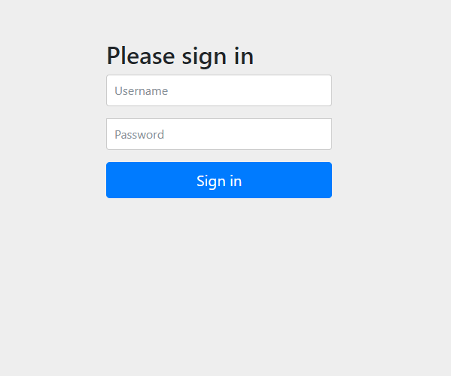
* This is the login page
* Upon Admin login, we get the following page to Manage Products, view reports, manage Categories.
* 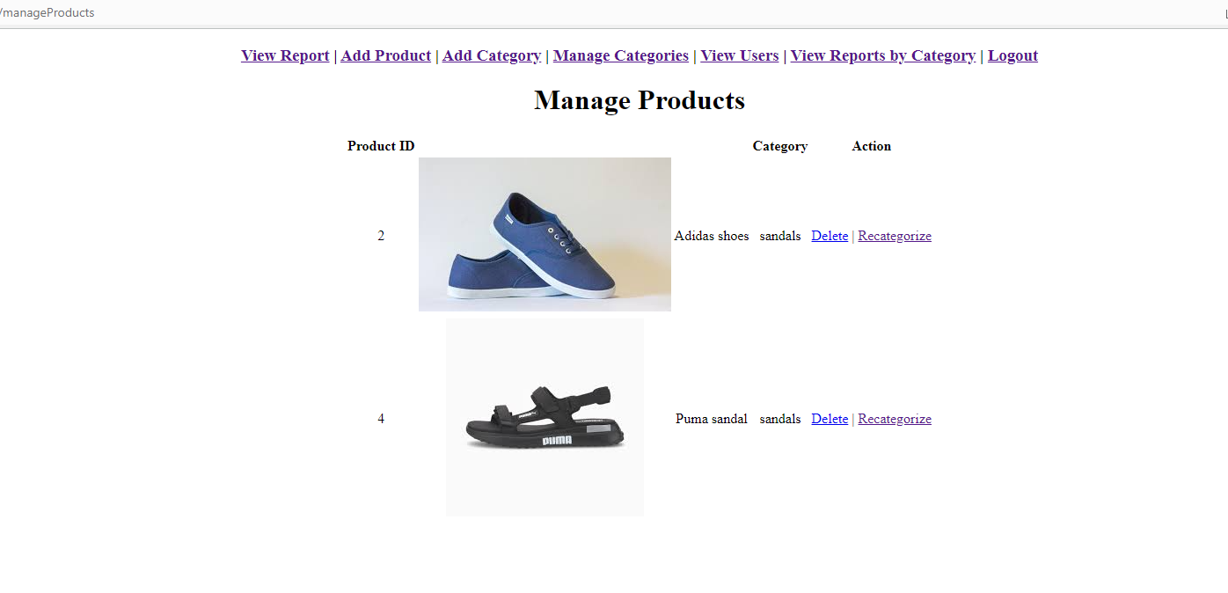
* For Adding Categories, the ADMIN will click on the Add Category link.
* 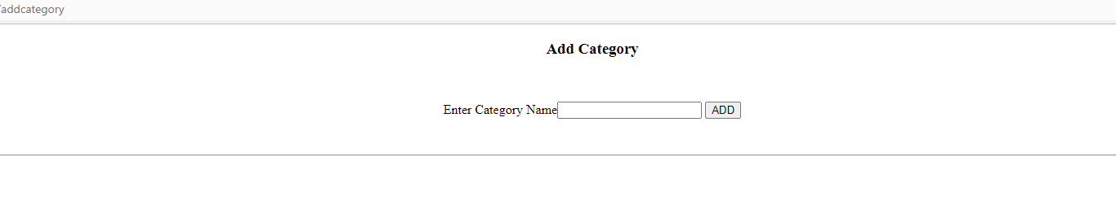
* For adding Products click on the Add Product link.
* 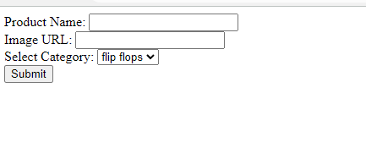
* Place the image in this directory- src/main/resources/static/images
* 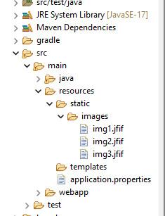
* Provide the name of the image along with extension in the Image URL field. Eg. Img3.jfif
* For viewing Orders, clink on View Report
* 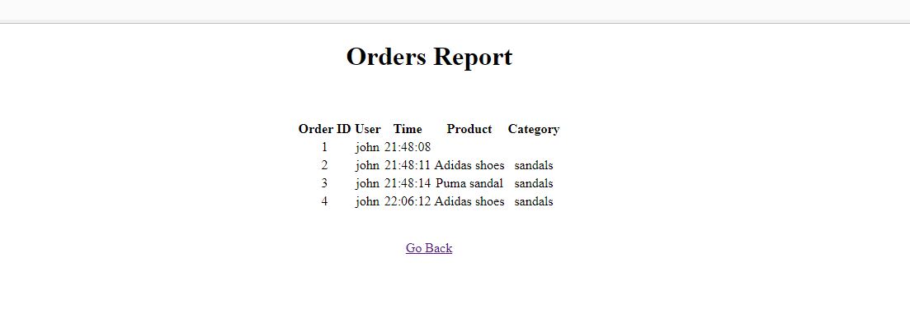
* For Viewing Orders filtered by a category and in ascending or descending order, click on View Reports by Category.
* 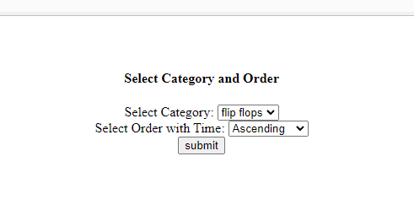

## **Sign up page for customers-**

* New Users should visit the URL: localhost:8081/register to view the registration page.
* 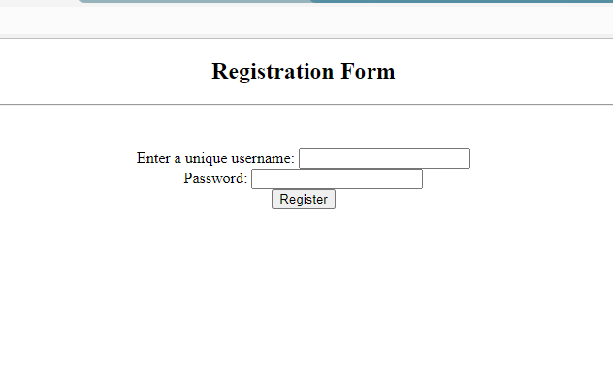
* After Signing up, the user can login as a customer.
* 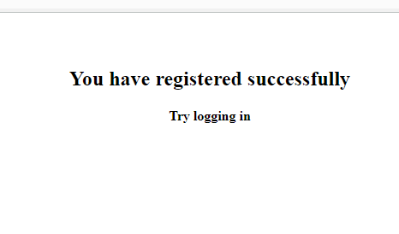

## **Customer Side**

* Customer will land on the following page-
* 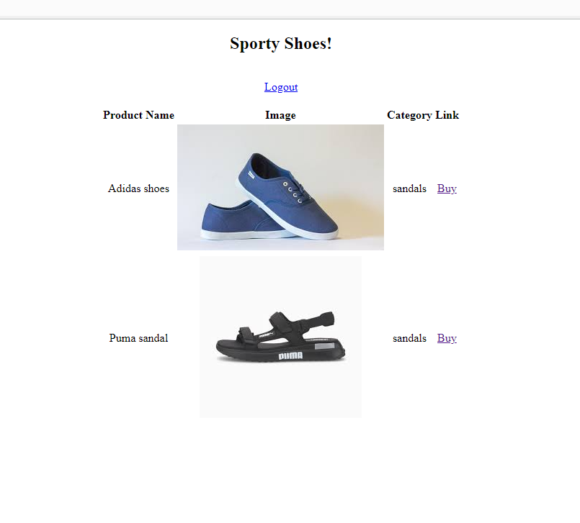
* Customer can click on the Buy link for any product to purchase.
* 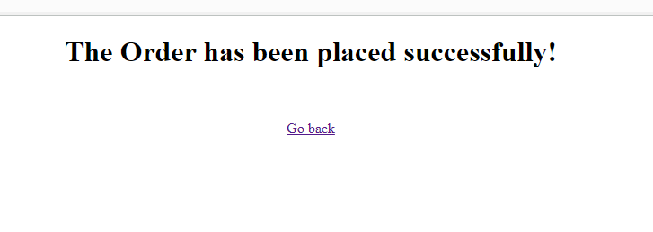
* https://github.com/IshaanGautam1/phase3project.git